## **Employee Management**

|  |  |
| --- | --- |
| Step No | API Call |
| 1 | Add Employee information |
| 2 | Get all Employee information |
| 3 | Get Employee by using Id |
| 4 | Update existing Employee information |
| 5 | Delete Employee information by id |

|  |  |
| --- | --- |
| **URI** | http://localhost:8082/employee |

1.Add Employee information

|  |  |  |
| --- | --- | --- |
| **URI** | http://localhost:8082/employee | |
| **Request** | Method | POST |
| Content-type | application/json |
| Header |  |
| Body | {            "firstname": "Abhishek",          "lastname":"Raj",          "emailId": "abhi.raj@softsol.com",          "age": 30      } |
| **Response** | {      "id": 5,      "firstname": "Abhishek",      "lastname": "Raj",      "emailId": "abhi.raj@softsol.com",      "age": 30  } | |
| **Error** |  | |
| **Reference** |  | |

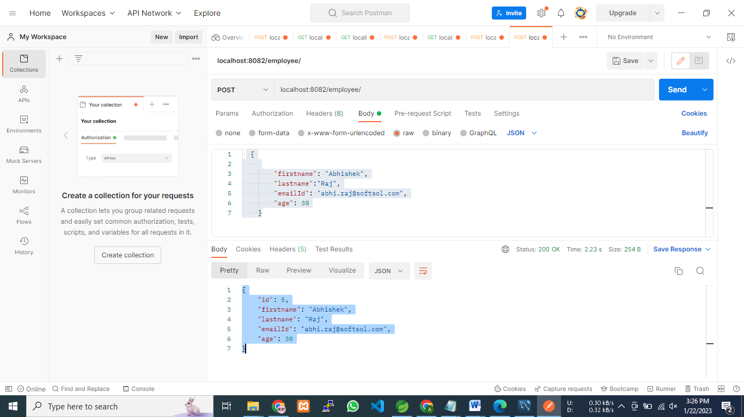

2.Update All Employee information

|  |  |  |
| --- | --- | --- |
| **URI** | http://localhost:8082/employee | |
| **Request** | Method | GET |
| Content-type | application/json |
| Header |  |
| Body | NA |
| **Response** | [      {          "id": 1,          "firstname": "Raj",          "lastname": "Verma",          "emailId": "raj.verma@imagine.com",          "age": 35      },      {          "id": 2,          "firstname": "Vaibhav",          "lastname": "Telang",          "emailId": "v.telang@futureready.com",          "age": 29      }  ] | |
| **Error** |  | |
| **Reference** |  | |

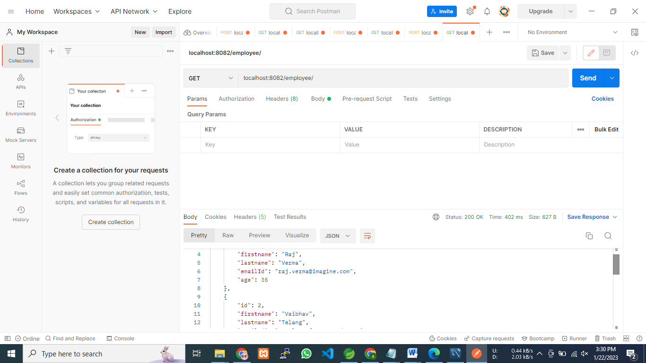

3.Get Employee information by Id

|  |  |  |
| --- | --- | --- |
| **URI** | http://localhost:8082/employee/{id} | |
| **Request** | Method | GET |
| Content-type | application/json |
| Header |  |
| Body | NA |
| **Response** | {      "id": 1,      "firstname": "Raj",      "lastname": "Verma",      "emailId": "raj.verma@imagine.com",      "age": 35  } | |
| **Error** |  | |
| **Reference** |  | |

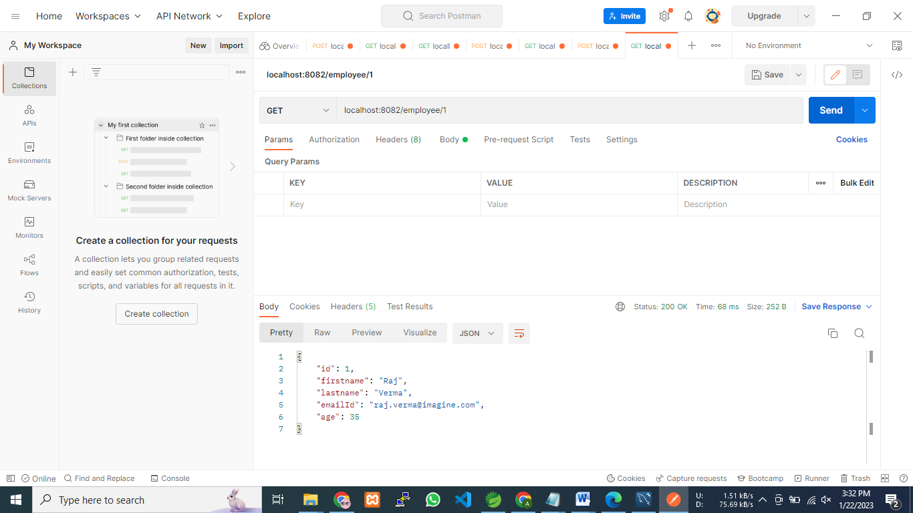

4.Delete policy information by Id

|  |  |  |
| --- | --- | --- |
| **URI** | http://localhost:8082/Employee/{id} | |
| **Request** | Method | DELETE |
| Content-type | application/json |
| Header |  |
| Body | NA |
| **Response** | {  Record is deleted.  } | |
| **Error** |  | |
| **Reference** |  | |

5. Update existing Employee information.

|  |  |  |
| --- | --- | --- |
| **URI** | http://localhost:8082/employee/{id} | |
| **Request** | Method | PUT |
| Content-type | application/json |
| Header |  |
| Body | {            "firstname": "Abhi",          "lastname":"Raj",          "emailId": "abhi.raj@softsol.com",          "age": 30      } |
| **Response** | {            "firstname": "Abhi",          "lastname":"Raj",          "emailId": "abhi.raj@softsol.com",          "age": 30      } | |
| **Error** |  | |
| **Reference** |  | |

